

***TECHNICAL PROJECT REPORT***

***WEIGHT MEASURMENT DEVICE***

**TEAM MEMBERS:**

|  |  |  |  |  |  |
| --- | --- | --- | --- | --- | --- |
| **S.NO.** | **Name** | **Department** | **Designation** | **Mobile** | **E-Mail** |
| **1** | Harish Kumar | IS | Student | 8958382030 | harishkumar8958382030@gmail.com |
| **2** | Vishal Thakur | IS | Student | 9690982460 | vishalsoam23@gmail.com |
| **3** | Ujjwal Sajlani | IS | Student | 8949496302 | ujjwalsajlani@gmail.com |
| **4** | Khushal Thakur | ECE | Mentor | 9646030764 | [khushal.thakur@cumail.in](mailto:khushal.thakur@cumail.in) |
| **5** | Anshul Sharma | ECE | Mentor | 9478697475 | [anshulsharma.ece@cumail.in](mailto:anshulsharma.ece@cumail.in) |
| **6** | Kiran Jot Singh | ECE | Mentor | 9463909689 | [kiranjotsingh.ece@cumail.in](mailto:kiranjotsingh.ece@cumail.in) |
| **7** | Divneet Singh Kapoor | ECE | Mentor | 9878422653 | divneet.ece@cumail.in |

**SECTION-1**

***IPR***

**Our project is helped to solve this problem …**

This device help in measuring weight of different objects. And digital weight machine is far more easier and simple as far as the design is concerned. While the analog machines drifts from zero quite frequently which you have to set by turning a thumb wheel and seeing the needle, the digital weight machine drift can be set easily, besides it’s readings are more accurate and precise.

Our project is completely portable.

It Can also save you from cheating shopkeeper who put weight below weighing scale to tamper with the actual weight.

**We are solving this problem by using…**

The software is built on Arduino-on-board principle. After burning the code into an ATMEGA328 ,the chip is taken out and put onto the production board. The initial reading may have errors as the probe is not yet calibrated. So press the push-button connected to digital pin 10 once and the probe will self calibrate and the initial reading of 0.0 will be shown. The zero set figure will then be stashed into the inbuilt EEPROM of the Arduino. Next time when you restart it after a switch off operation, the zero set reading will be read from the EEPROM and then the internal calibration will be adjusted according to that and would be shown on the top line. The 2nd line will show 0.0.

While taking reading if you find that the reading reduces when you increase load then just reverse the white and green wires and it will be solved.

The software consists of HX711 header files and the arduino sketch. First add the library files to the Arduino IDE and then run the sketch. To calibrate the probe, press the push button once.

**EXISTING STATE-OF-THE-ART AND DRAWBACK IN EXISTING STATE-OF-THE-ART**

|  |  |  |
| --- | --- | --- |
| **S.NO.** | **Existing state of art** | **Drawback in existing state of art** |
| 1 | The model consist of arduino, breadboard, load cell and LCD to display the weight of an object | The load cell has maximum capacity of 40 kg. |

**BLOCK DIAGRAM**

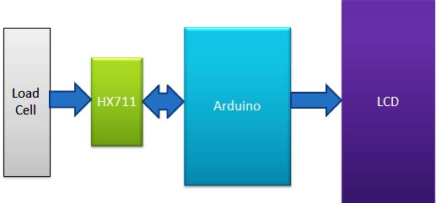

**SECTION-2**

**MATERIALS**

* Arduino Uno
* Load cell (40kg)
* HX711 Load cell Amplifier Module
* 16x2 LCD
* Connecting wires
* USB cable
* Breadboard
* Nut bolts, Frame and base

**CIRCUIT DIAGRAM**

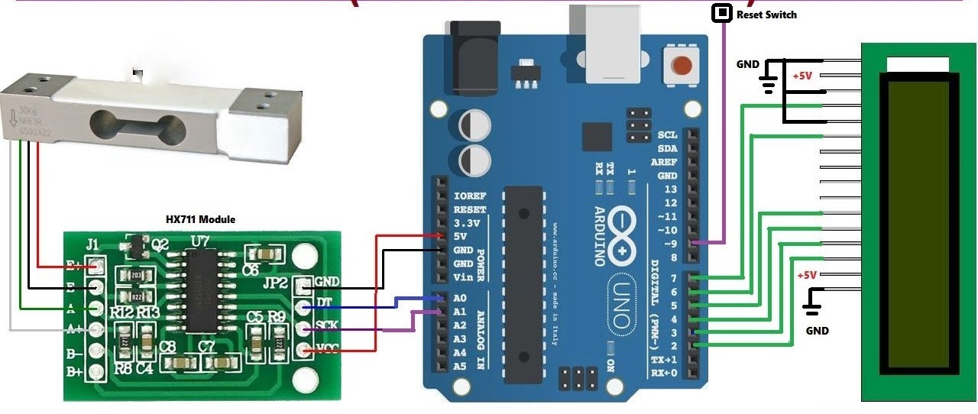

**STEPS OF CIRCUIT COMPLETION**

**Load Cell and HX711 Weight Sensor Module:**

**Load cell is transducer which transforms force or pressure into electrical output**. Magnitude of this electrical output is directly proportion to the force being applied. Load cells have strain gauge, which deforms when pressure is applied on it. And then strain gauge generates electrical signal on deformation as its effective resistance changes on deformation. A load cell usually consists of four strain gauges in a Wheatstone bridge configuration. Load cell comes in various ranges like 5kg, 10kg, 100kg and more, here we have used Load cell, which can weight upto 40kg.

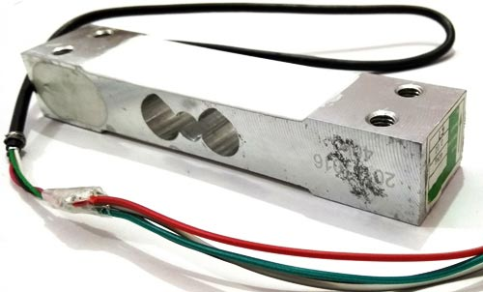

Now the electrical signals generated by Load cell is in few millivolts, so they need to be further amplify by some amplifier and hence HX711 Weighing Sensor comes into picture. **HX711 Weighing Sensor Module** has HX711 chip, which is a 24 high precision A/D converter ([Analog to digital converter](https://circuitdigest.com/microcontroller-projects/arduino-uno-adc-tutorial)). HX711 has two analog input channels and we can get gain up to128 by programming these channels. **So HX711 module amplifies the low electric output** of Load cells and then this amplified & digitally converted signal is fed into the Arduino to derive the weight.

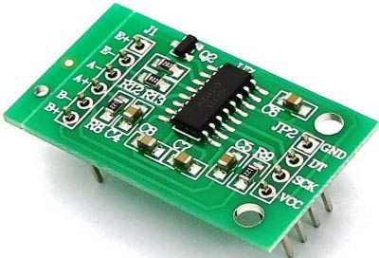

Load cell is connected with HX711 Load cell Amplifier using four wires. These four wires are Red, Black, White and Green/Blue. There may be slight variation in colors of wires from module to module. Below the connection details and diagram:

* RED Wire is connected to E+
* BLACK Wire is connected to E-
* WHITE Wire is connected to A-
* GREEN Wire is connected to A+

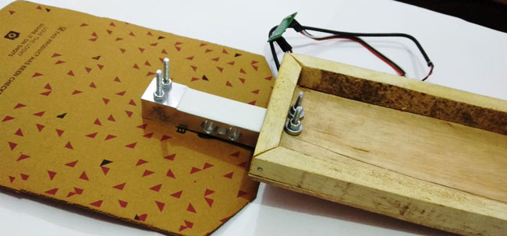

### Circuit Explanation:

Connections for this project are easy and schematic is given below. [16x2 LCD](https://circuitdigest.com/article/16x2-lcd-display-module-pinout-datasheet) pins RS, EN, d4, d5, d6, and d7 are connected with pin number 8, 9, 10, 11, 12 and 13 of Arduino respectively. HX711 Module’s DT and SCK pins are directly connected with Arduino's pin A0 and A1.

### Working Explanation:

Working of this **Arduino Weight Measurement project** is easy. Before going into details, first we have to **calibrate this system**for measuring correct weight. When user will power it up then system will automatically start calibrating. And if user wants to calibrate it manually then press the push button. We have created a function void calibrate() for calibration purpose, check the code below.

**For calibration**, wait for LCD indication for putting 100 gram over the load cell as shown in below picture. When LCD will show “put 100g” then put the 100g weight over the load cell and wait. After some seconds calibration process will be finished. After calibration user may put any weight (max 40kg) over the load cell and can get the value over LCD in grams.

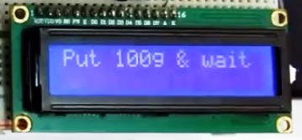

In this project, we have used **Arduino** to control whole the process. **Load cell** senses the weight and supplies a electrical analog voltage to **HX711 Load Amplifier Module**. HX711 is a 24bit ADC, which amplifies and digitally converts the Load cell output. Then this amplified value is fed to the Arduino. Now Arduino calculate the output of HX711 and converts that into the weight values in grams and show it on LCD. A **push button** is used for calibrating the system.

**PROGRAM CODE**